John Hancock - Project Coeus Backend Services Assembly v1.0
Deployment Guide

Revision History
Author | Revision Number | Date
TCSASSEMBLER | 1.0 | 05/03/2016

Deployment Instructions 3
1. Organization of Submission 3
2. Application Setup 3
3. Database Setup 3
4. Setup / Configure Active Directory: 4
Note: This guide is for Windows Server 2012. 4
4.1. Add new Server roles Active Directory Domain Services. 4
4.2. Configure Active Directory Domain Services: 4
4.3. Configure Users and Roles 8
5. IIS Deployment Instructions 13
6. Visual Studio Deployment Instructions 19
8. Web API Verification 21
9. Resource Contact List 38

Deployment Instructions

Organization of Submission
  - Directory Structure
Directory / File Name | Description
Database | Contains all required scripts to setup the database.
Docs | Contains the deployment guide, and Postman exported collection.
Lib | The dependency libraries.
Src | The source code.

Application Setup
Preconditions:
- Windows Server 2008+ with .NET Framework 4.5+ and Active Directory installed. (Required)
- Microsoft SQL Server 2012+ is installed. (Required)
- Microsoft IIS 8.5 (Optional, can also run in IIS Express)
- Visual Studio 2015 is installed. (Required to build solution and run tests. For deployment in IIS – optional.)

Database Setup
Install the scripts under Database directory.
- Create database

- Execute the below scripts one by one:

- DDL.sql
- [optionally] TestData.sql – required to verify Web API with Postman.

Setup / Configure Active Directory:

Note: This guide is for Windows Server 2012.

Add new Server roles Active Directory Domain Services.
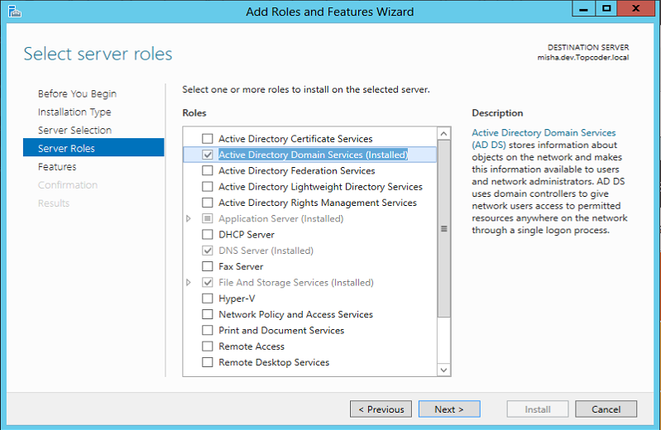

Configure Active Directory Domain Services:
After install, open AD Administrative Center:

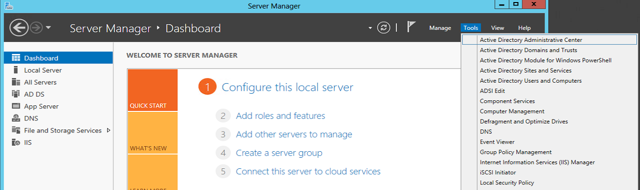

4.2.1 After opening, follow the instructions to configure Active Directory Domain Services

4.2.1.1 Add a new forest
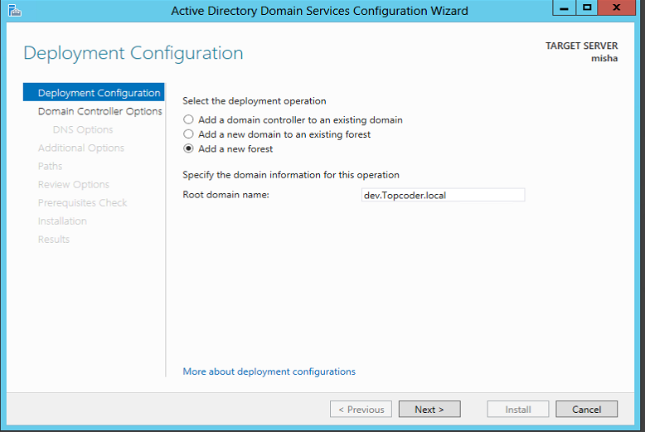

4.2.1.2 Setup the forest functional level and DSRM password:
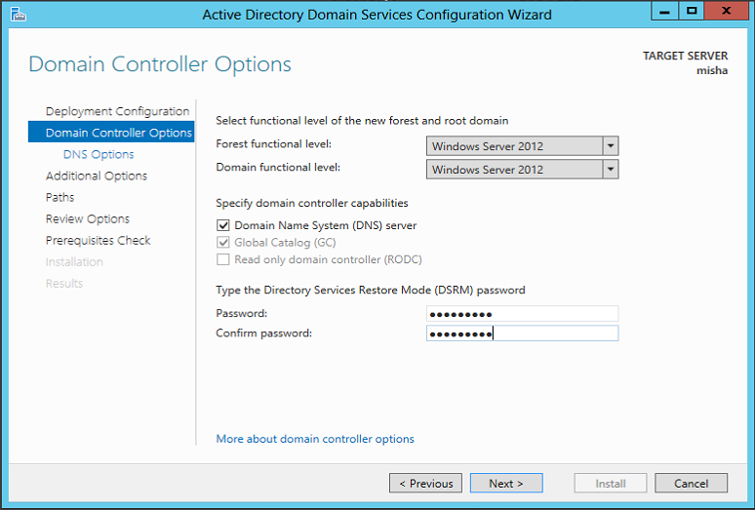

4.2.1.3 DNS delegation options
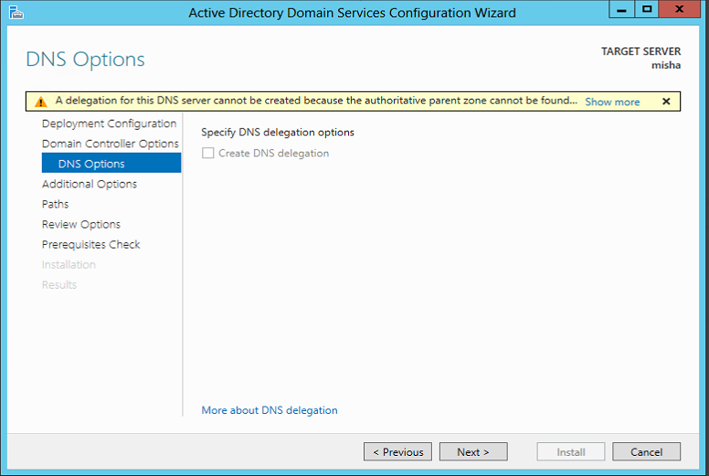

4.2.1.4 Domain Name
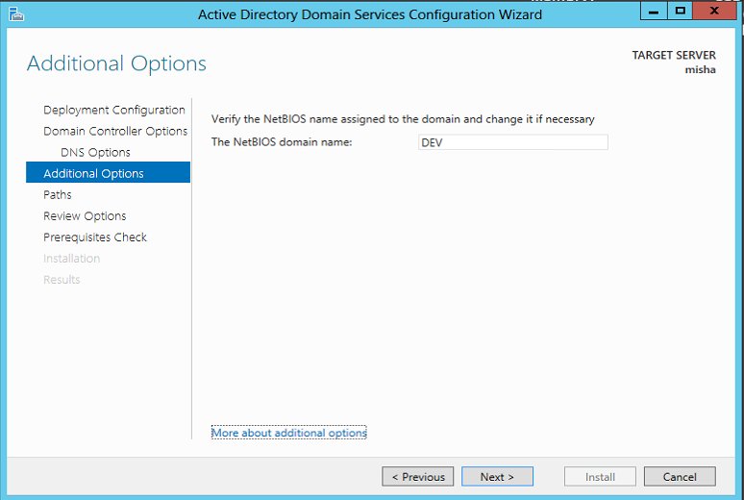

4.2.1.5 Paths
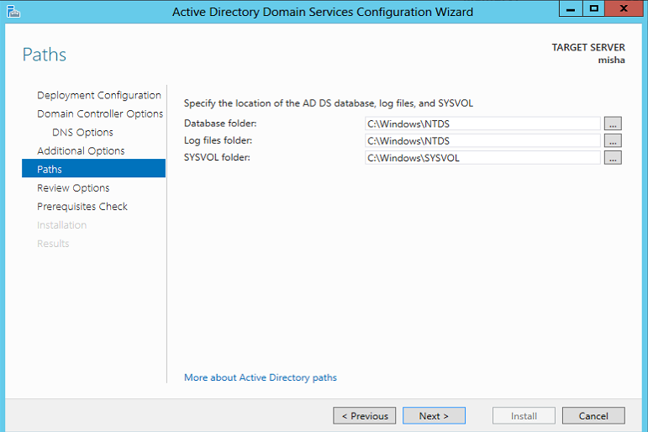

4.2.1.6 Review Options
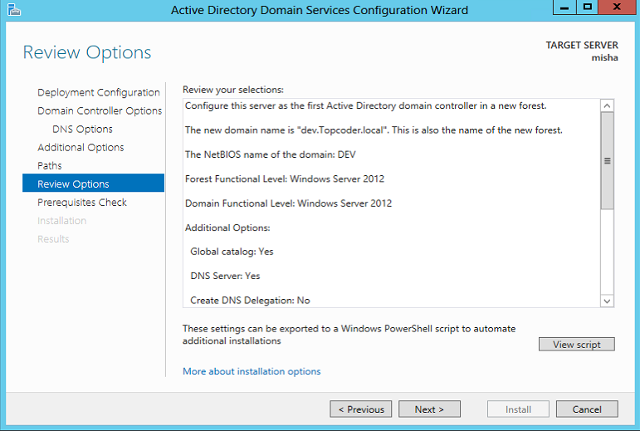

4.2.1.7 Prerequisites and Install
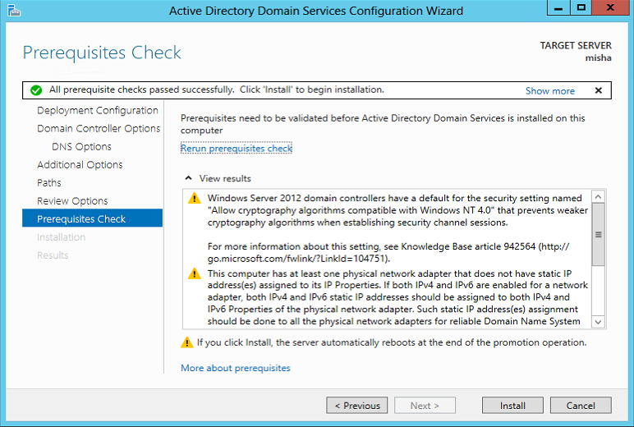
After finishing, it will restart the server to complete installation.

Configure Users and Roles

Open Active Directory Administrative Center to configure user and roles:
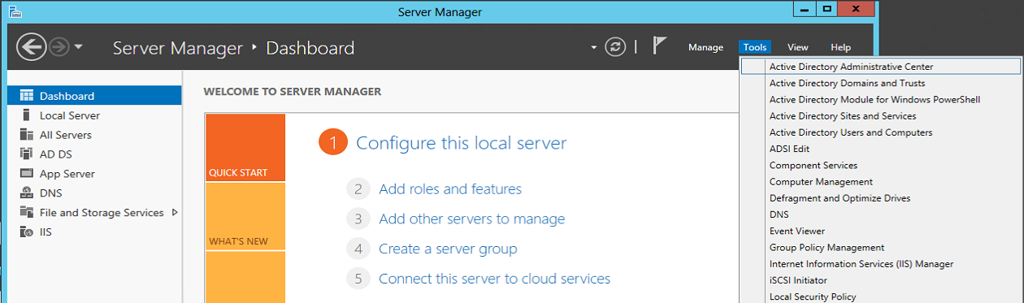

Select users:
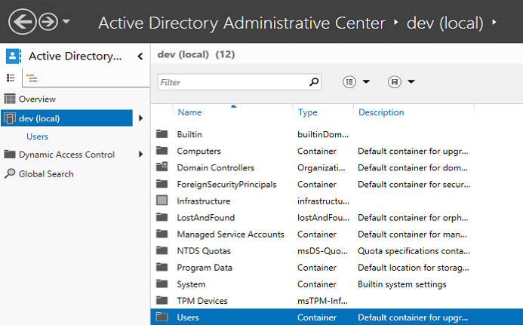

4.3.1 Roles / Groups

4.3.1.1 Select New->Group
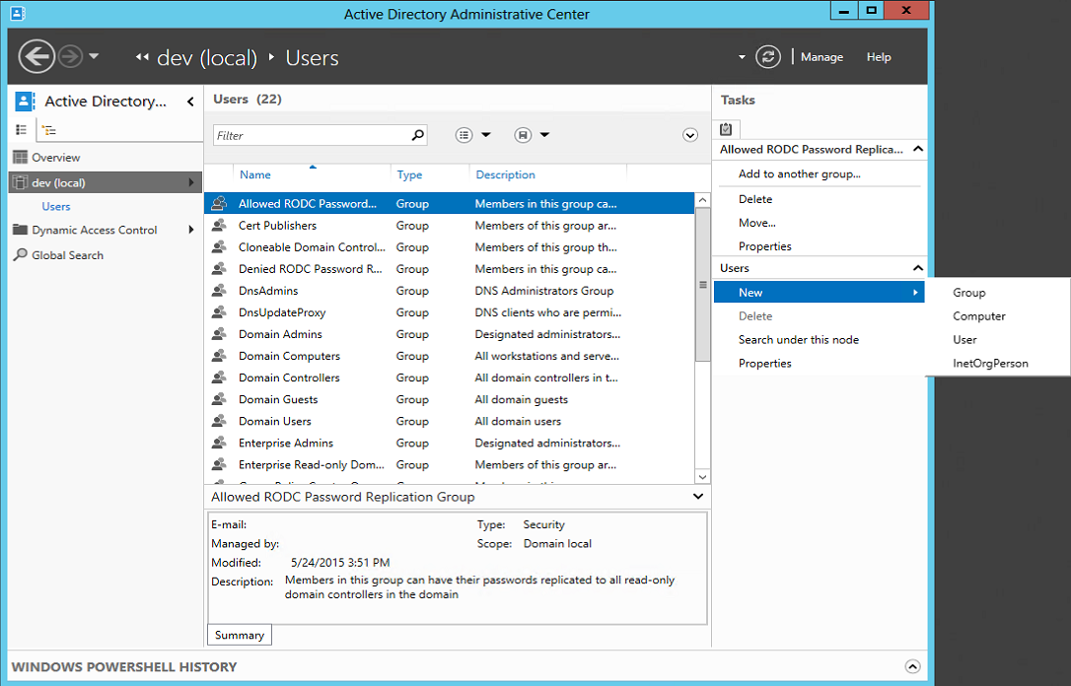

4.3.1.2 Add Groups – CoeusOwners, CoeusBUFunctionalApprovers, CoeusBURiskManagementApprovers, CoeusDivisionalRiskManagementApprovers, CoeusAdmins.
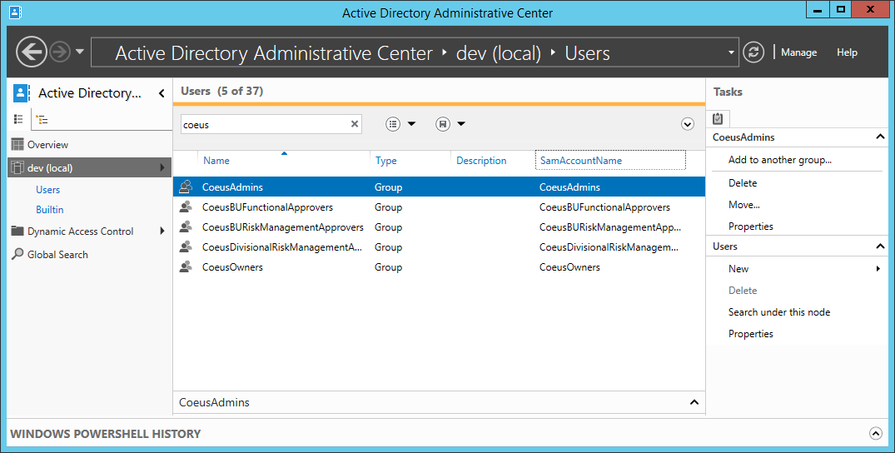

4.3.2 Users

4.3.2.1. Create CoeusAdmin user, set password to “CoeusAdminPassword” and check “Password never expires”. Set First name to Coeus and Last name to Admin. Add CoeusAdmin to CoeusAdmins group.
Note: Ensure password complexity check is disabled - http://www.avoiderrors.net/windows-server-2012-remove-password-complexity/
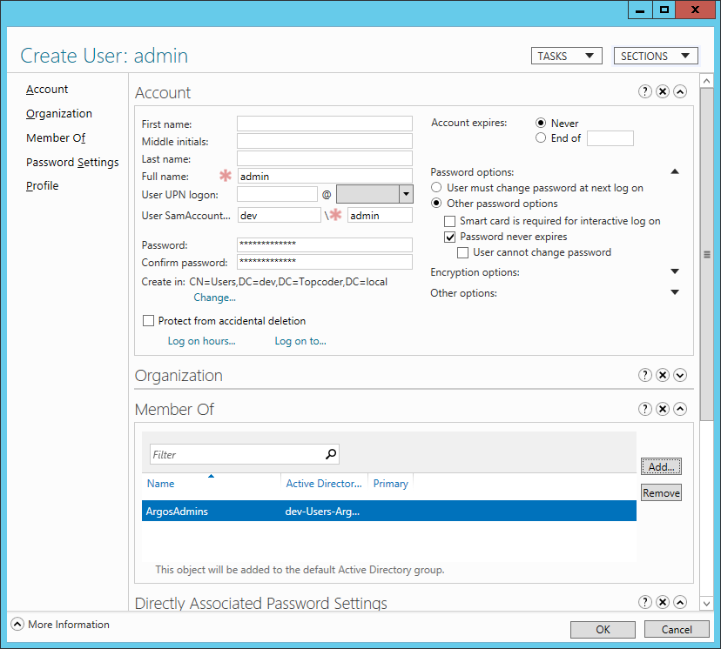

Set CoeusAdmin business units:
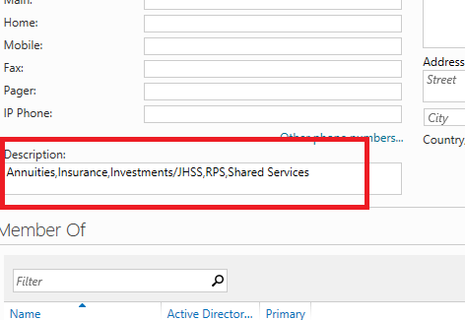

The mapping between User properties and AD attributes is following:
FirstName => givenName
LastName => sn
BusinessUnits => description

Please note that attribute mappings are configurable. Current configuration is just an example and is using attributes from top of the list for simplicity. Use appropriate properties for your deployment environment!

Similarly add following users:
Username | FirstName | LastName
CoeusOwner | Coeus | Owner
CoeusBUFunctionalApprover | Coeus | BUFunctionalApprover
CoeusBURiskManagementApprover | Coeus | BURiskManagementApprover
CoeusDivisionalRiskManagementApprover | Coeus | DivisionalRiskManagementApprover
CoeusAdmin | Coeus | Admin

Add users to corresponding groups (group names are same as username + ‘s’).
Set password for each user to {Username}Password.
Set business units for all users to ‘Annuities,Insurance,Investments/JHSS,RPS,Shared Services.

IIS Deployment Instructions

If you don’t want to use IIS yet, you can use Visual Studio to run it directly. Please refer to section 6.

  - Extract the package.

  - Setup the database. Refer to section #3.

  - Deploy the \src\JohnHancock.ProjectCoeus directory to IIS with “DefaultAppPool” application pool.
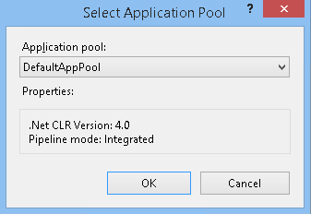
  - Configure the Web.config under \src\JohnHancock.ProjectArgos\ directory. Make it fits your environment. Please make sure you configure Active Directory credentials, most of other properties have default configuration values and should work without any modifications.

Node name | Description
<connectionStrings> | Connection strings to database.
<unity > | Contains all configuration values that will be injected to services.
<log4net> | Log4net configuration.

BaseService configuration properties:

Property | Description | Required
Logger | The log4net ILog instance. | Yes

LookupService configuration properties:

Property | Description | Required
all properties from the BaseService class

AssessmentService configuration properties:

Property | Description | Required
all properties from the BaseService class
UserService | The User service. | Yes
LookupService | The Lookup service. | Yes
RiskScoreCalculator | The risk score calculator. | Yes

SecurityService configuration properties:

Property | Description | Required
all properties from the BaseService class
UserService | The User service. | Yes
ADUsersDomain | The Active Directory users’ domain path. | Yes
ADAdminUsername | The Active Directory admin user name. | Yes
ADAdminPassword | The Active Directory admin user password. | Yes
TokenExpiration | The token expiration time in minutes. | Yes

UserService configuration properties:

Property | Description | Required
all properties from the BaseService class
LookupService | The Lookup service. | Yes
ADUsersDomain | The Active Directory users’ domain path. | Yes
ADAdminUsername | The Active Directory admin user name. | Yes
ADAdminPassword | The Active Directory admin password. | Yes
ADPropertyNameMapping | The Active Directory user property mappings. | Yes
ADGroupNameMapping | The database Role to Active Directory Group mappings. | Yes

RiskScoreCalculator configuration properties:

Property | Description | Required
Logger | The log4net ILog instance. | Yes
Expressions | The mapping from risk types to risk score expressions. | Yes

LookupController configuration properties:

Property | Description | Required
LookupService | The Lookup service for retrieving lookup entities. | Yes

SecurityController configuration properties:

Property | Description | Required
SecurityService | The Security service for authentication and token management operations. | Yes

AssessmentController configuration properties:

Property | Description | Required
AssessmentService | The assessment service for managing assessments. | Yes
UserService | The user service for retrieving users. | Yes
AuditService | The audit service creating audit records. | Yes

AuthorizationFilter configuration properties:

Property | Description | Required
Logger | The log4net ILog instance. | Yes
UserService | The User service for user authorization. | Yes

ExceptionFilter configuration properties:

Property | Description | Required
Logger | The log4net ILog instance. | Yes

LoggingActionFilter configuration properties:

Property | Description | Required
Logger | The log4net ILog instance. | Yes

Sample log4net configuration:
<log4net>
<appender name="FileAppender" type="log4net.Appender.FileAppender">
<file value="weblog.txt" />
<appendToFile value="true" />
<layout type="log4net.Layout.PatternLayout">
<conversionPattern value="%date [%thread] %-5level %logger - %message%newline" />
</layout>
</appender>
<logger name="default">
<level value="DEBUG" />
<appender-ref ref="FileAppender" />
</logger>
</log4net>

Sample Services & Controllers Unity configuration:
<unity>
{type aliases removed for clarity}
<containers>
<container>
<!-- ADPropertyNameMapping for UserService -->
<register type="IDictionaryString" mapTo="DictionaryString" name="ADPropertyNameMapping">
<constructor />
<method name="Add">
<param name="key" value="FirstName" />
<param name="value" value="givenName" />
</method>
<method name="Add">
<param name="key" value="LastName" />
<param name="value" value="sn" />
</method>
<method name="Add">
<param name="key" value="BusinessUnits" />
<param name="value" value="adminDescription" />
</method>
</register>

<!-- ADGroupNameMapping for UserService -->
<register type="IDictionaryString" mapTo="DictionaryString" name="ADGroupNameMapping">
<constructor />
<method name="Add">
<param name="key" value="Owner" />
<param name="value" value="CoeusOwners" />
</method>
<method name="Add">
<param name="key" value="BUFunctionalApprover" />
<param name="value" value="CoeusBUFunctionalApprovers" />
</method>
<method name="Add">
<param name="key" value="BURiskManagementApprover" />
<param name="value" value="CoeusBURiskManagementApprovers" />
</method>
<method name="Add">
<param name="key" value="DivisionalRiskManagementApprover" />
<param name="value" value="CoeusDivisionalRiskManagementApprovers" />
</method>
<method name="Add">
<param name="key" value="Admin" />
<param name="value" value="CoeusAdmins" />
</method>
</register>

<!-- Expressions for RiskScoreCalculator, note that expressions are trivial for testing purposes -->
<register type="IDictionaryString" mapTo="DictionaryString" name="Expressions">
<constructor />
<method name="Add">
<param name="key" value="ResidualOverallRiskScore" />
<param name="value" value="assessment.OverallRiskRatingCommentary.Length * 2.5" />
</method>
<method name="Add">
<param name="key" value="ResidualCategoryRiskScore" />
<param name="value" value="assessment.BUFunctionalApproveTime.Value.Day + category.Id" />
</method>
<method name="Add">
<param name="key" value="LikelihoodOfOccurrenceOverallRiskScore" />
<param name="value" value="assessment.BUFunctionalApproveTime.Value.Day + 7.3" />
</method>
<method name="Add">
<param name="key" value="RiskExposureOverallRiskScore" />
<param name="value" value="assessment.SubmitterUsername.Length + 2.34" />
</method>
<method name="Add">
<param name="key" value="KeyControlsMaturityOverallRiskScore" />
<param name="value" value="assessment.SubmitterUsername.Length / 0.3" />
</method>
</register>

<register type="IAssessmentService" mapTo="AssessmentService">
<property name="LookupService" />
<property name="RiskScoreCalculator" />
<property name="UserService" />
<property name="Logger" />
<method name="CheckConfiguration" />
<lifetime type="singleton" />
</register>
<register type="IAuditService" mapTo="AuditService">
<property name="Logger" />
<method name="CheckConfiguration" />
<lifetime type="singleton" />
</register>
<register type="ILookupService" mapTo="LookupService">
<property name="Logger" />
<method name="CheckConfiguration" />
<lifetime type="singleton" />
</register>
<register type="ISecurityService" mapTo="SecurityService">
<property name="ADUsersDomain" value="DEV" />
<property name="ADAdminUsername" value="{set_username}" />
<property name="ADAdminPassword" value="{set_password}" />
<property name="TokenExpiration" value="60" />
<property name="UserService" />
<property name="Logger" />
<method name="CheckConfiguration" />
<lifetime type="singleton" />
</register>
<register type="IUserService" mapTo="UserService">
<property name="ADUsersDomain" value="LDAP://CN=Users,DC=dev,DC=Topcoder,DC=local" />
<property name="ADAdminUsername" value="{set_username}" />
<property name="ADAdminPassword" value="{set_password}" />
<property name="ADPropertyNameMapping" dependencyName="ADPropertyNameMapping" />
<property name="ADGroupNameMapping" dependencyName="ADGroupNameMapping" />
<property name="LookupService" />
<property name="Logger" />
<method name="CheckConfiguration" />
<lifetime type="singleton" />
</register>
<register type="IRiskScoreCalculator" mapTo="RiskScoreCalculator">
<property name="Logger" />
<property name="Expressions" dependencyName="Expressions" />
<method name="CheckConfiguration" />
<lifetime type="singleton" />
</register>
<register type="AuthorizationFilter">
<property name="Logger" />
<property name="SecurityService" />
<method name="CheckConfiguration" />
<lifetime type="singleton" />
</register>
<register type="ExceptionFilter">
<property name="Logger" />
<method name="CheckConfiguration" />
<lifetime type="singleton" />
</register>
<register type="LoggingActionFilter">
<property name="Logger" />
<method name="CheckConfiguration" />
<lifetime type="singleton" />
</register>
<register type="AssessmentController">
<property name="AssessmentService" />
<property name="UserService" />
<property name="AuditService" />
<method name="CheckConfiguration" />
</register>
<register type="LookupController">
<property name="LookupService" />
<method name="CheckConfiguration" />
</register>
<register type="SecurityController">
<property name="SecurityService" />
<method name="CheckConfiguration" />
</register>
</container>
</containers>
</unity>

Visual Studio Deployment Instructions
This deployment can provide the quick environment for development.

  - Extract the package.

  - Setup the database. Refer to section #3.

  - Setup Active Directory Domain Services. Refer to section 4.
  - Open the file \src\JohnHancock.ProjectCoeus.sln in Visual Studio (under administrator role).

  - Configure the Web.config (refer section 5.4) in project JohnHancock.ProjectCoeus Make it fits your environment.

  - Set JohnHancock.ProjectCoeus as startup project.

  - Click menu Debug -> Start Without Debugging (or Press Ctrl + F5) to host Web API.

  - Open the browser and navigate to the base application url (like http://web_site_url/). The following is the success page. Navigate to verification section, to see how you can verify that application works correctly.
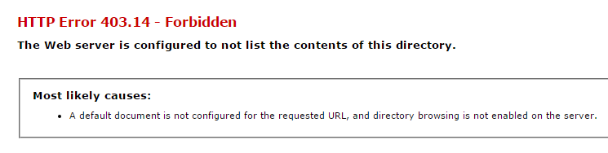
- Verification

  - Follow section #6 to set up deployment.

  - Configure the App.config in project JohnHancock.ProjectCoeus.Tests. Make it fits your environment. Refer section 5.4 for more details. Please note that App.config doesn’t require configuration for Controllers and Action Filters.
You need to update AD configuration for
- ISecurityService
- IUserService

You also need to update following settings in App.config file:
<appSettings>
<!-- the path for exported files -->
<add key="ExportedFilesPath" value="d:\tc2016\temp\exported_files\" />
</appSettings>

  - Click menu Test -> Run -> All Tests
As a result you should see all tests passed:
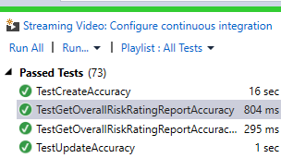

Web API Verification
- Host application in either IIS or by using VS 2015 as described in previous sections.
- Import the test data: \Database\TestData.sql to database.
- Open PostMan Chrome App
- Import collection from \docs\JohnHancock.ProjectCoeus.json.postman_collection by pressing highlighted button:
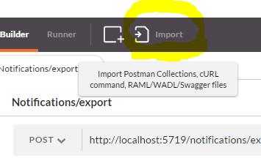

All predefined queries should be loaded:
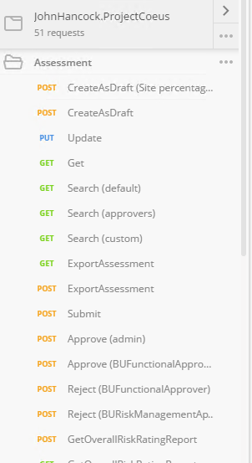
- Import environment variables from \docs\JohnHancock.ProjectCoeus.postman_environment
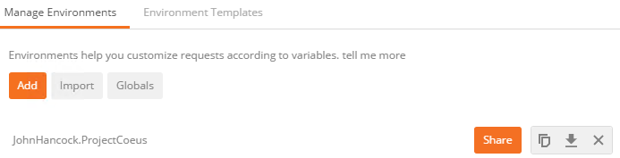
  - Security.Login (fake)
Expected:
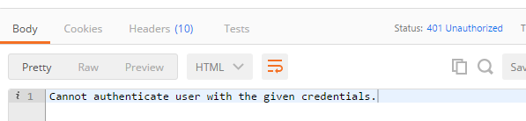
Note: In some cases you might need to re-import test data, otherwise request may not work.

  - Security.Login (admin)
Expected:
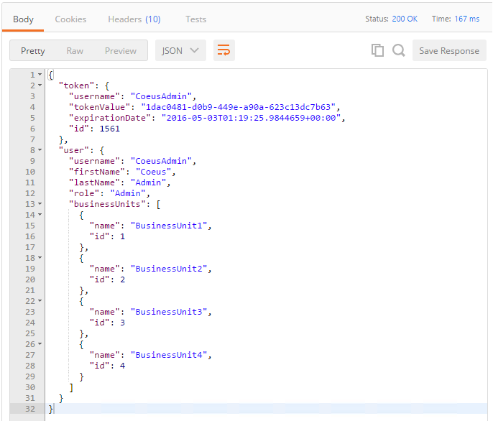

  - Security.Revoke
Expected: 200 status with empty response body

  - Lookup.GetAllBusinessUnits
Expected:
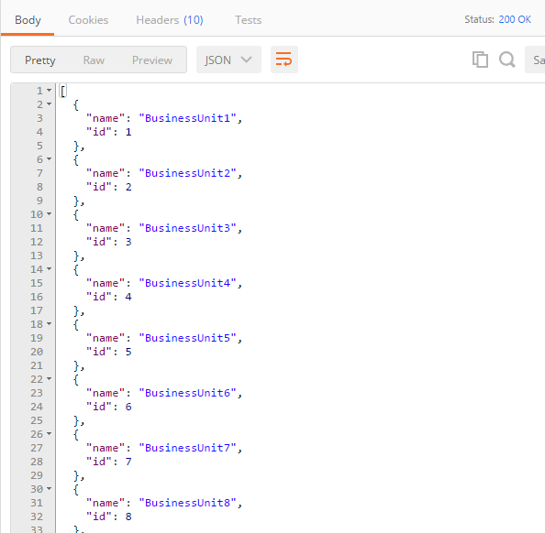

  - Lookup.GetAllKPISLAs
Expected:
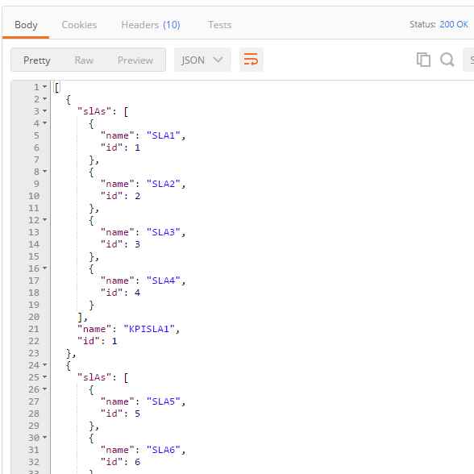

  - Assessment.CreateAsDraft (Site percentage sum != 100)
Expected:
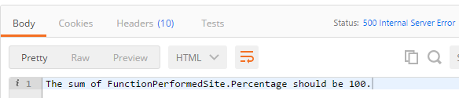

  - Assessment.CreateAsDraft
Expected:
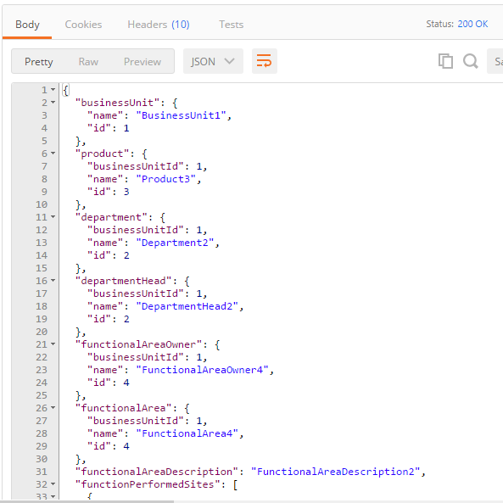

  - Assessment.Update
Expected:
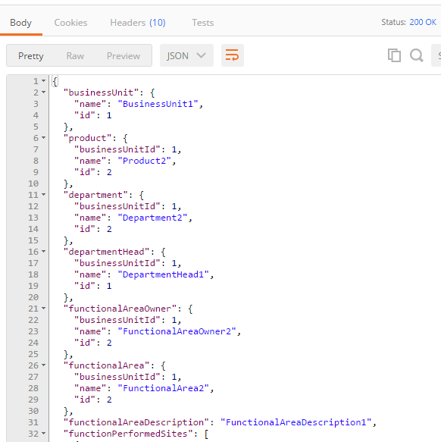

  - Assessment.Get
Expected:
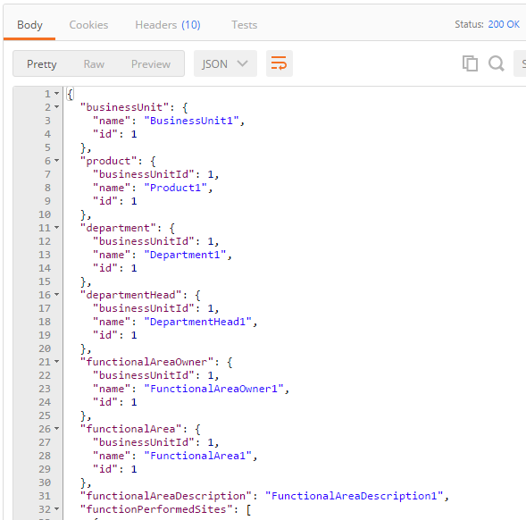

  - Assessment.Search (default)
Expected:
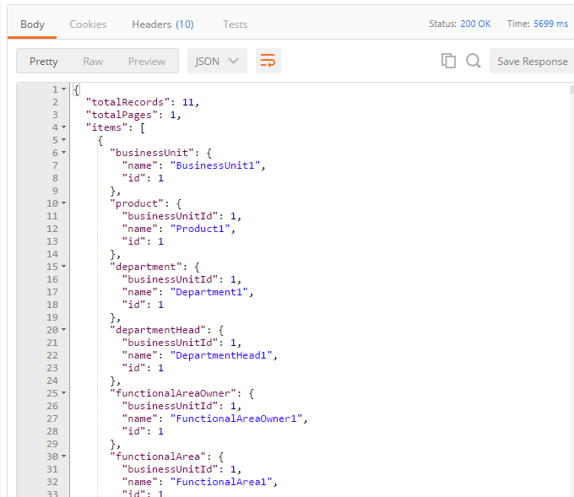

  - Assessment.Search (approvers)
Expected:
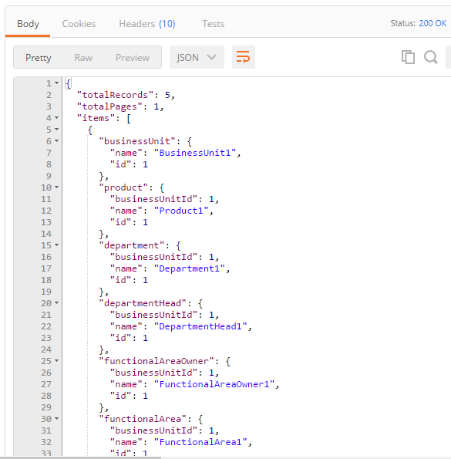

  - Assessment.Search (custom)
Expected:
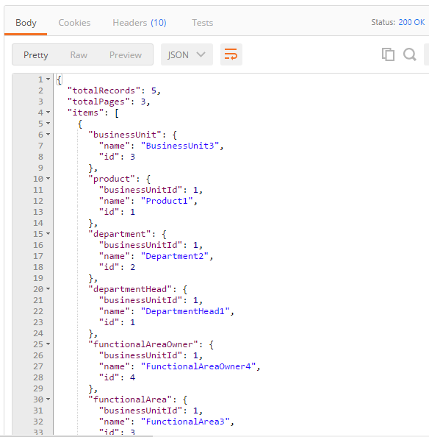

  - Assessment.ExportAssessment
For this request you should click “Send and Download”. Once file is downloaded and opened in Excel, it should look following.
Tab 1:
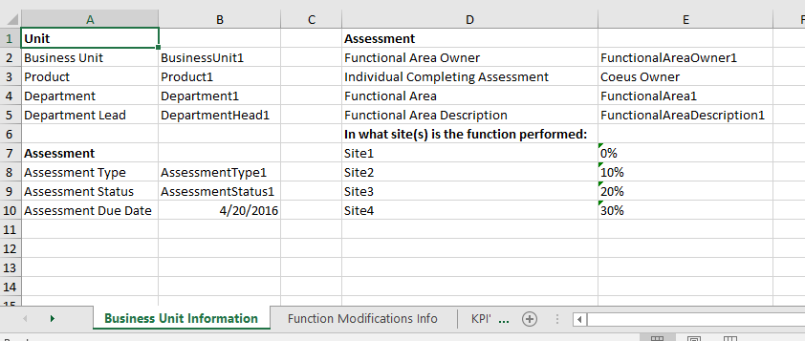

Tab 2:
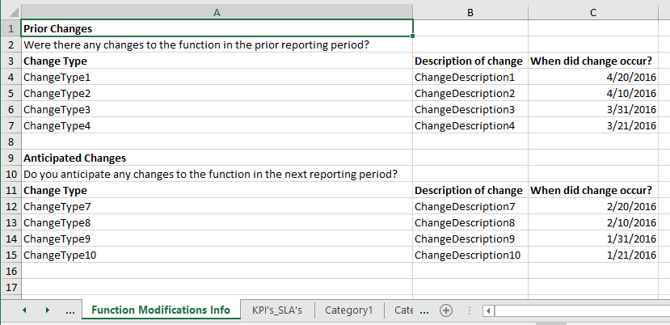

Tab 3:
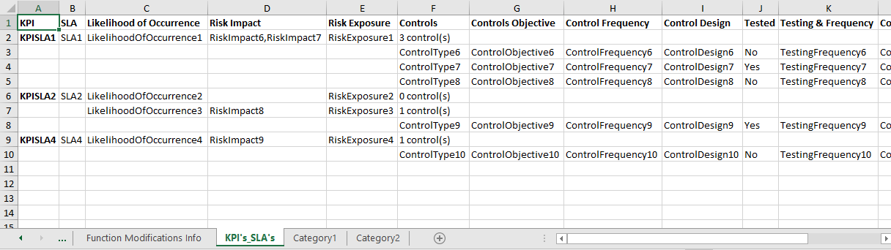

  - Assessment.Submit
Expected:
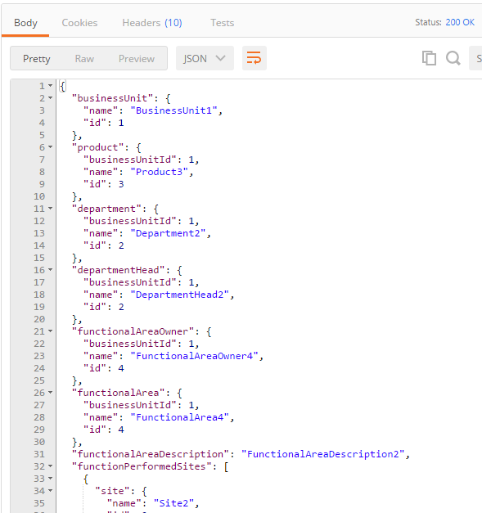

  - Assessment.Approve (admin)
Expected:
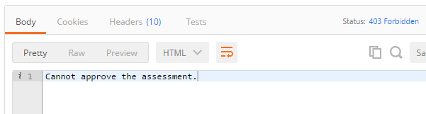

  - Assessment.Approve (BUFunctionalApprover)
Expected: 200 status with empty response

  - Assessment.Reject (BUFunctionalApprover)
Expected:
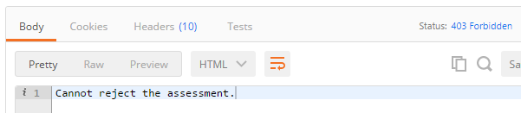

  - Assessment.Reject (BURiskManagementApprover)
Expected: 200 status with empty response

  - Assessment.GetOverallRiskRatingReport
Expected:
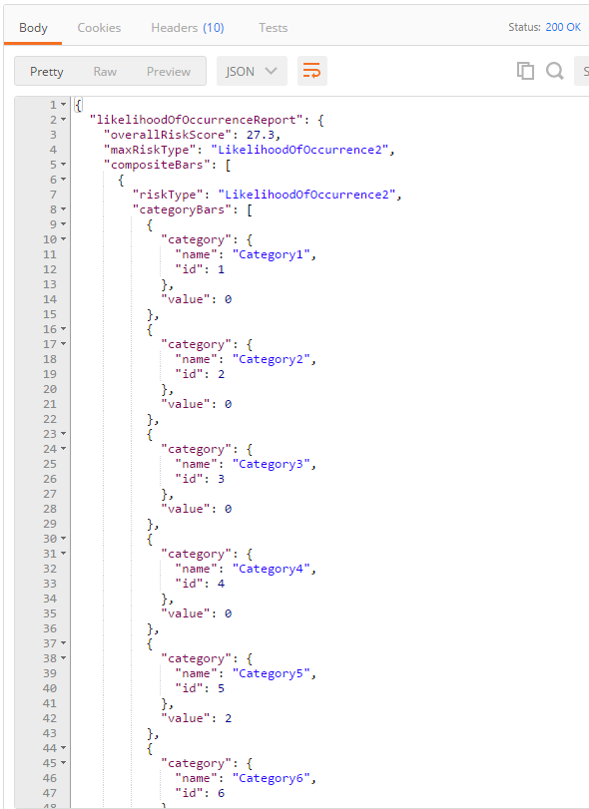

  - Assessment.GetDraftCount
Expected:
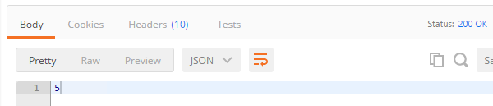

  - Assessment.GetDraftAssessments
Expected:
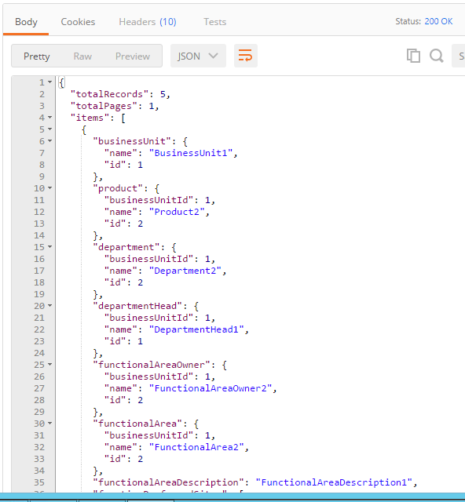

  - Assessment.GetAwaitingApprovalAssessments (pagination)
Expected:
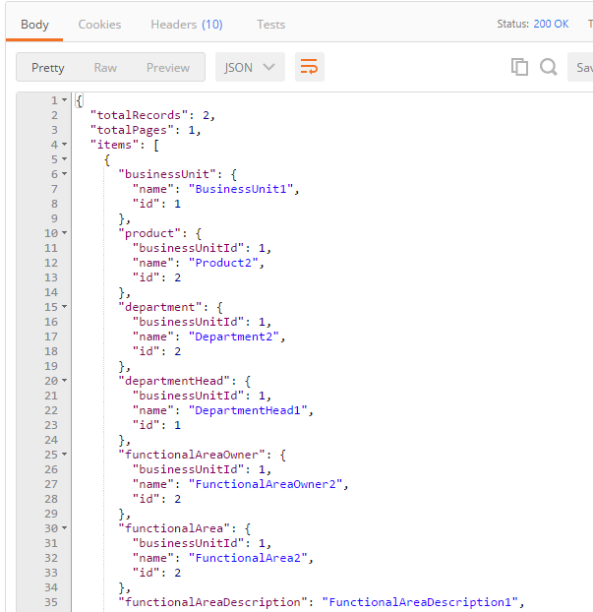

  - Other requests not covered in this guide are similar.

Resource Contact List

Name | Resource Email

